Memory Trace X-Axis Rescale Problem

# Intent

I need to create arbitrary memory traces on-instrument. In general, any property of the trace can change, including the x-axis range. When the x-axis range changes, I need to be able to update the existing traces to reflect the new range.

The instrument will not be sweeping (it will be in manual sweep mode, stopped) while these traces are being updated.

# Problem

When changing the range of the x-axis, the memory trace is not updated to reflect it.  
See example below.

# Scope

Confirmed on:  
- ZNB firmware 2.60 beta 1.226  
- ZVA firmware 3.60

Sweep modes effected*:  
- Linear frequency sweep  
- Logarithmic frequency sweep  
- Segmented sweep  
- Power sweep

I have not tested CW or Time sweep modes.

The customer specifically has several ZVAs; I need the ZVA fix most urgently. Also, I am specifically interested in memory traces in power sweep and segmented sweep modes.

# Work-around

The only work-around I’ve found is deleting the effected channels and traces, then recreating them to force the VNA to regenerate the x-axis.

This potential work-around is NOT acceptable for my application. The user is configuring the display in a very particular way (trace formats, diagram areas, diagram titles, per diagram and/or per trace scale, trace scale coupling, markers, marker coupling etc etc) and I need to maintain it. Expecting the user to recreate the setup is unreasonable. Trying to recreate the setup programmatically is unreasonable, given the number and complexity of the settings to maintain.

# Example

**In this example I will use SCPI commands to start from a preset instrument, create a channel, a diagram, a data trace and memory trace (see figure: Initial Trace). Then I will change the channel range and update the memory trace values to demonstrate the problem (see figure: Truncated Trace).**

**Initial Trace***X-Axis: -20 dBm to 0 dBm*

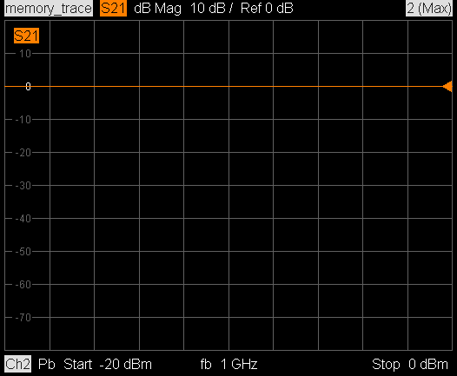

**Truncated trace***X-axis: -30 dBm to 10 dBm*

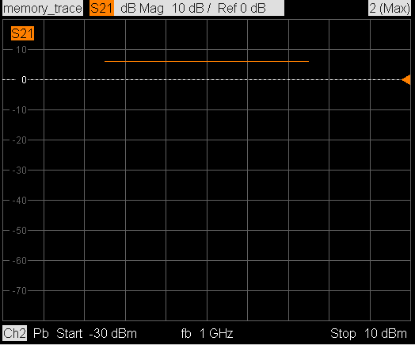

**# Preset the instrument  
*RST**

**# Wait for preset to complete  
*OPC?**

**# The instrument should be in a factory preset state.  
# It should have  
# - 1 channel (Ch1)  
# - 1 diagram (#1)  
# - 1 trace (Trc1)**

**# Put the only channel into manual sweep mode  
INIT1:CONT 0**

**# Create diagram 2  
DISP:WIND2:STAT 1**

**# Create channel 2  
CONF:CHAN2 1**

**# Set channel 2 to power sweep  
# As noted above, frequency sweeps are also effected  
SENS2:SWE:TYPE POW**

**# Set start, stop, number of points  
SOUR2:POW:STAR -20  
SOUR2:POW:STOP 0  
SENS2:SWE:POIN 3**

**# Create S21 data trace in channel 2  
CALC2:PAR:SDEF 'data_trace', 'S21'**

**# Create memory trace  
TRAC:COPY 'memory_trace', 'data_trace'**

**# Write custom values to memory trace  
# Note: these are complex values that correspond  
# to points of value 0 dB, 0 deg  
CALC2:PAR:SEL 'memory_trace'  
CALC2:DATA SDAT,1,0,1,0,1,0**

**# Assign the memory trace to diagram 2  
DISP:WIND2:TRAC:EFE 'memory_trace'**

**Note: At this point, memory_trace in diagram 2 should look like the Initial Trace figure above**

**# Change x-axis values  
SOUR2:POW:STAR -20  
SOUR2:POW:STOP 0**

**# Change memory trace values  
# New points: ~6 dB, 0 deg  
CALC2:DATA SDAT,2,0,2,0,2,0**

**Note: Now memory_trace in diagram 2 is truncated to the old x-axis range.**